COMPILE DESIGN

SYMBOL TABLE REPORT

J PAVAN SAI

AP20110010580

Symbol table is an important data structure created and maintained by compilers in order to store information about the occurrence of various entities such as variable names, function names, objects, classes, interfaces, etc.

Symbol table is used by both the analysis and the synthesis parts of a compiler.

A symbol table is simply a table which can be either linear or a hash table. It maintains an entry for each name.

Variable names and constants

Procedure and function names

Literal constants and strings

Compiler generated temporaries

Labels in source languages

Above items are stored in symbol table

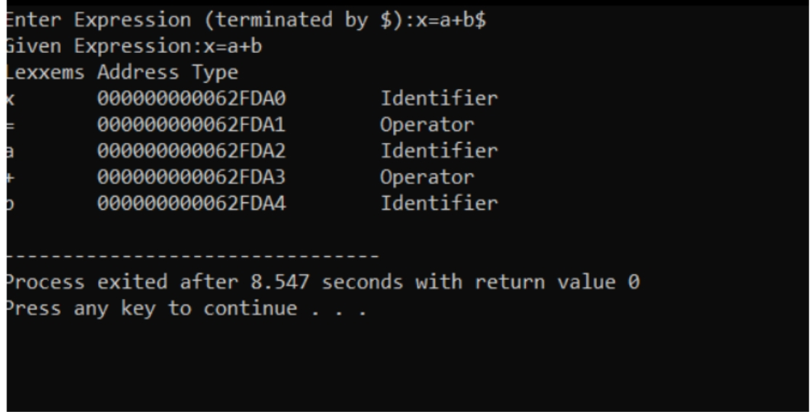

In Symbol Table

, we are taking expressions from user which contain some integers,characters,and some operators. It will identify characters as identifiers , digits as constants. In the above example

X,a,b are identifiers and

=,+ are operators.